**Closing the gap in retirement savings**

**June 11, 2015**

Bottom of Form

The good news? Americans are actively saving for retirement. The not-so-good news? They may not be saving enough.

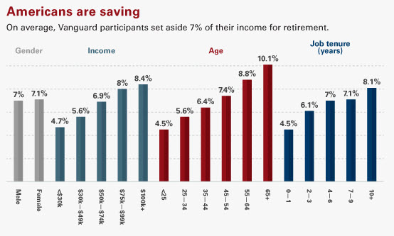

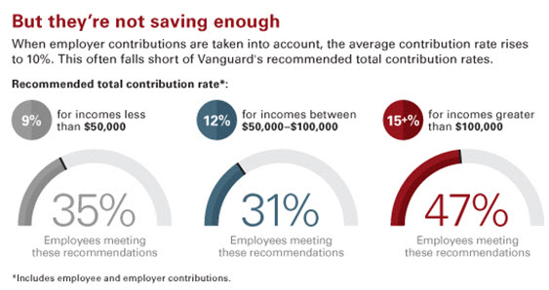

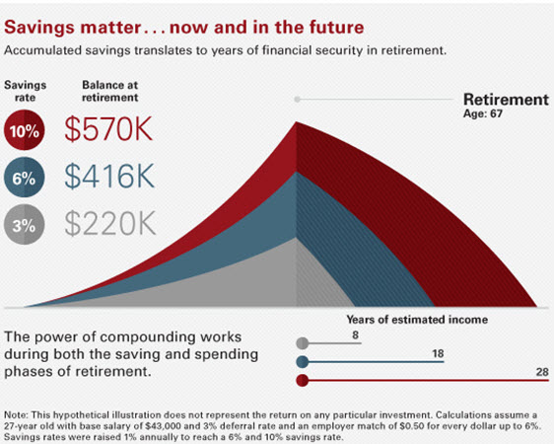

*Source: Vanguard 2015.